**UNIT-2, TECHNICAL WRITING-I**

Introduction: Technical Writing

It can be defined as the practice of articulating any product or service in the form of a document where processes are defined such as software manuals or instructional materials.

**Qualities associated with Technical Writing:**

* Needs to be written precisely so that it can be understood by users or target audience.
* To understand the target audience so that your document or technical content may connect with them quickly.
* Write stepwise guidance about how to perform something or some process.

**Characteristics of Technical Writing**

* Clear: Technical writing requires concise sentences that leave no room for misunderstanding.
* Precise: The language must be describing objects and procedures in an exact manner.
* Straightforward: It requires information in a way that is direct and straight to the point without the use of literary devices.
* Easily understandable: Avoid words that people may not understand.
* Structured: Technical writing is very structured. The audience needs to be able to rely on technical writing for step-by-step instructions.
* Denotative meanings: This type of writing relies on the denotative meanings of words to ensure that misunderstanding do not occur due to differing interpretations based on connotation.
* Detailed: Technical writing is very detailed and informative, leaving nothing to the imagination. The best example of technical writing is a Textbook.
* Problem-solving focus: Readers use these documents to learn how to perform certain tasks or gain technical information, so they should be easy to follow and organized in a way that’s easy to refer to as questions come up.

Examples: User manuals, lab reports, driving directions, medical prescriptions, etc.

Technical Vocabulary

Technical vocabulary is composed of words with a specialized meaning used usually in one specific subject.

Examples: Fabrication, communication, friction, generation etc.

Etymology: The study of the origin of words and the way in which their meanings have changed throughout history.

Business Letter Vs. E-Mail

* Letter is a hard copy, and the e-mail is a soft copy – an electronic message.
* After you compose a business letter, you print it, seal it in an envelope, affix postage and use a service such as Indian Postal Service or an overnight delivery company to send the letter to the recipient. A business e-mail, on the other hand, also is composed usually using a computer or electronic means, but it is electronically dispatched to the recipient in a matter of just a few seconds.

The commonly used format for business letters and e-mails is block style.

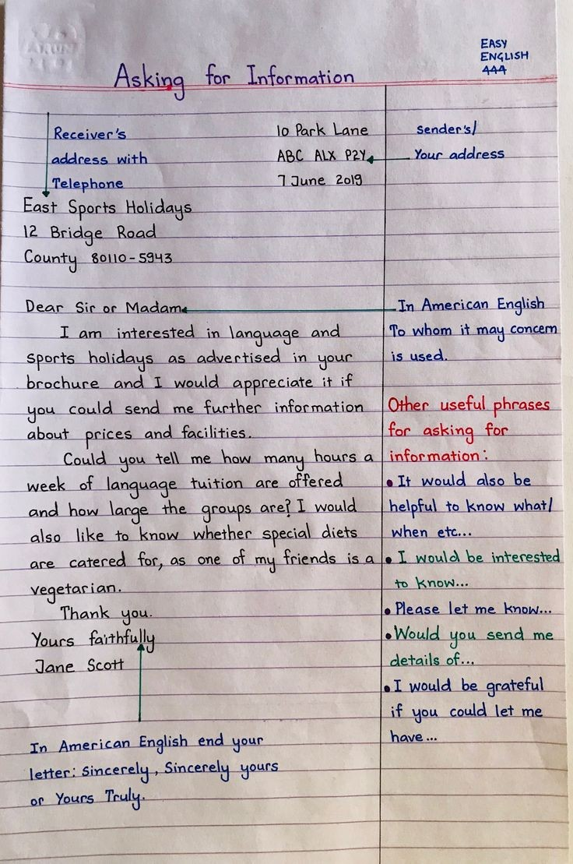

**Job Application and Résumé**

* CV (Curriculum Vitae, which means course of life in Latin) contains a high level of detail about your achievements, a great deal more than just a career biography

C.V. generally lists out skills, jobs, degrees, and professional affiliations the applicant has acquired, usually in a functional/ reverse chronological order

* CV is used primarily when applying for academic, educational, scientific or research positions
* depends upon material

Resume Is a French word meaning "summary", signifies a summary of one's employment, education, and other skills, used in applying for a new position

* Resume starts with a brief Summary of Qualifications, followed by Areas of Strength or Industry Expertise in keywords, followed by Professional Experience in reverse chronological order.
* Any job
* One page, sometimes two pages

It is a kind of Cover letter used to apply for a job. It serves the purpose to set the tone of the resume

Basic Structure:

Introduction: application for the job

Details: qualification and eligibility

Conclusion: request for interview

Résumé: Résumé is a brief about the Applicant

1. Is a French word meaning "summary", signifies a summary of one's employment, education, and other skills, used in applying for a new position
2. It starts with a brief Summary of Qualifications, followed by Areas of Strength or Industry Expertise in keywords, followed by Professional Experience in reverse chronological order.
3. A résumé is a tool used to market your skills, experiences, education and accomplishments to employers. Your résumé will assist you in getting an interview and making the important first impression. Tailor your résumé to the kind of job (s) you are seeking. If the jobs are different, your résumé should be adapted to reflect the differences between employers and their requirements. The qualifications listed in your résumé should match those listed in the job description of the position for which you are applying.

Basics of Résumé

Cap the top of your resume with:

* + Full name
  + Complete address (may include both permanent and present address)
  + Phone number (can list work/cell phone number - designate each with an “C” “H” or “W”)
  + E-mail address

Basics of Résumé content

* + Categories used will vary based on your qualifications and/or intended goal
  + Consider several versions of resume for different targets
  + Describe more than duties/tasks performed
  + indicate skills developed/demonstrated
  + indicate value added – accomplishments

Objective: The objective is an optional category that indicates the type of work you are seeking. Employers prefer objectives that are specific and concise. If you know the exact position you are pursuing or field that you are considering, you may include an objective. Otherwise, you may omit this category.

Good Objective: An internship at Computer Sciences Corporation in computer programming.

OR

A management training position at Bank of America.

Bad Objective: An internship utilizing my skills and training.

OR

A position in financial services where I can learn and progress in my career.

Education

* Degrees should be listed in reverse chronology Include only those schools in which you earned a degree
* Names and locations of schools or programs
* Graduation date
* Degrees or certificates
* Major, minor or cognate
* Grade point average
* Awards/Honors/Scholarships (consider a separate section if more than 3)
* Study abroad experiences

Related Course Work

* This category is optional and can also be part of the Education section
* Mainly used when you are lacking related experience but want to demonstrate specific knowledge
* List the titles of courses you’ve taken that relate to the position for which you are applying

Experience

* Include full-time and part-time jobs, summer positions, volunteer work, military service, internships, self-employment, research projects, and even activities if they are directly related to the position
* In some cases you may wish to divide this category into two sections: one called Related Experience and one called Additional Experience

Additional Categories

Honours, Activities, Research, Professional Affiliations

You may specifically want to list:

* + - Activities or leadership positions that demonstrate job related skills
    - Honors or awards (Scholarships may or may not be relevant)

Skills

* + We recommend a separate section listing computer skills. Be specific, listing product names and version numbers if possible
  + Students seeking technology positions specifically should break this list down into subcategories such as programming languages, hardware, software, operating systems, databases, peripherals, etc.
  + If you speak more than one language, you should also list them here, indicating your level of proficiency in each

Computer

• Languages: C++, java, HTML, CSS

• Applications: Microsoft Office, Eclipse

Mat Lab

• Machines: Unix, Linux, Solaris

Languages

• Fluent in French and Spanish, Basic knowledge of German

Achievements and honours

Co curricular and extracurricular Activities

Strengths

Hobbies and Interests

References

**Notice, Agenda & Minutes of Meeting**

**Notice** : A notice is a written or printed information usually displayed publicly. A notice can also be defined as a format designed to convey the same information to a number of different people.

We issue notices to inform, advertise, instruct and warn. Notices are displayed at public places such as railway stations, bus stands, hospitals, schools, colleges, universities, govt. offices etc.

**Qualities of a good notice:**

An effective notice should be accurate, clear, concise and decisive.

Use correct, unambiguous, appropriate and polite language.

Has short words and sentences.Uses an attractive layout.

Reader-friendly – appealing, convincing and understandable. It is typed in a manner that it could be read easily from a distance.

Notice for convening a meeting: A notice for convening a meeting contains following items:

Name of organization, Place of meeting, Date and time of meeting, Type of meeting (e.g. committee meeting, annual general meeting etc.) Purpose of meeting

The notice is circulated to the members and those who are supposed to attend the meeting and sent within reasonable time, generally two weeks in advance.

**Agenda**: Agenda is an official list of things to be done or dealt with at a particular meeting. An agenda is a list/programme of items to be discussed at a meeting. An agenda is generally prepared by the Secretary of the organization/committee in consultation with the chairperson and distributed to the members before the meeting. An agenda is signed by the Secretary.

Writing agenda : Make a list of those, who will attend the meeting. Make a list of items/subjects to be discussed in the meeting. Note the purpose of including a topic in the agenda. The motive may be seeking information, brainstorming, discussion, making a decision etc.

Don’t include inappropriate points/items.Note which people are related to which topic.Make a possible list of objectives for the meeting and review the agenda according to those objectives.

An Agenda should include:

1. Location
2. Date
3. Timings
4. Topic
5. Topic Description
6. Time distributed to each topic
7. Name of each member

**Language used in agenda**: Four important features of language used in agenda are Brevity or economy, Clarity, Informativeness and relevance

Why agenda is necessary? Fruitful meetings keep organization moving. (no decisions can be made from loosely organizes meetings.) If a meeting has well planned agenda or a definite purpose, then it will be fruitful otherwise, it would be a waste of time.

**Main advantages of agenda:** Confirms the date, time and place of meeting. directs the course of meeting, prevents digressions (diversions) , gives members time to think, form or seek opinion or collect information, presents manageable list of items, helps members to come to a consensus.

**Minutes**

Minutes (of meeting) : The official record of discussion held and decisions taken at a meeting are called as minutes. The minutes are generally written by the secretary of the committee, who holds the meeting and signed by both the secretary and the chairperson.

It is always written in the past tense, and the reason behind this is that it is prepared after the meeting ends.

Items to be included:

1. Time and Date of the meetings
2. Name of the Members
3. All the topics discussed in details.
4. Decisions taken

Importance of minutes: Minutes serve as an aid to memory. Minutes provide a basis for action. Minutes also act as a means of informing the absent members, about the discussion held and decisions taken in the meeting.

**Agenda vs Minutes**

The main difference between Agenda and Minutes is that the Agenda is the list prepared before the meeting that contains all the topics that are to be discussed and is in the future tense, whereas Minutes are the conclusion of the meeting prepared at the end.